Question 1

C-Code

#include <stdio.h>

int main(){

    int num ;

    printf("Enter a Number to check if it is the multiple of 3 : ") ;

    scanf("%d",&num) ;

    if(num%3== 0){

        printf("%d is the multiple of 3",num);

    }

    else{

        printf("%d is not the multiple of 3",num);

    }

}

COMPILER’S OUTPUT

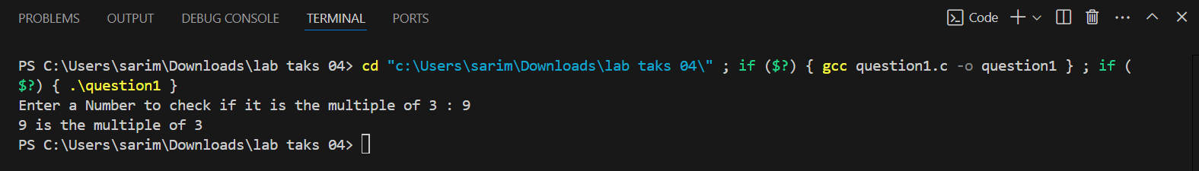

FLOW CHART

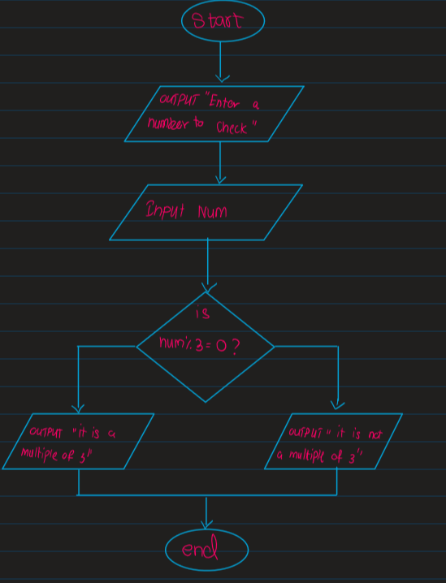

Question 2

C-CODE

#include <stdio.h>

int main(){

    int num1,num2,answer ;

    char operator ;

    printf("Enter number1 : ") ;

    scanf("%d", &num1) ;

    printf("Enter number2 : ") ;

    scanf("%d",&num2) ;

    printf("Enter operator : ") ;

    scanf(" %c",&operator) ;

    switch(operator){

        case '+':

            answer = num1+num2 ;

            break ;

        case '-':

            answer = num1 - num2 ;

            break ;

        case '*':

            answer = num1*num2 ;

            break ;

        case  '/' :

            answer = num1 / num2 ;

            break ;

    }

    printf("Your answer is %d",answer) ;

}

COMPILER OUTPUT

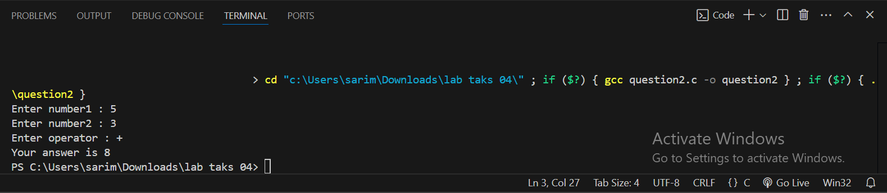

FLOW CHART

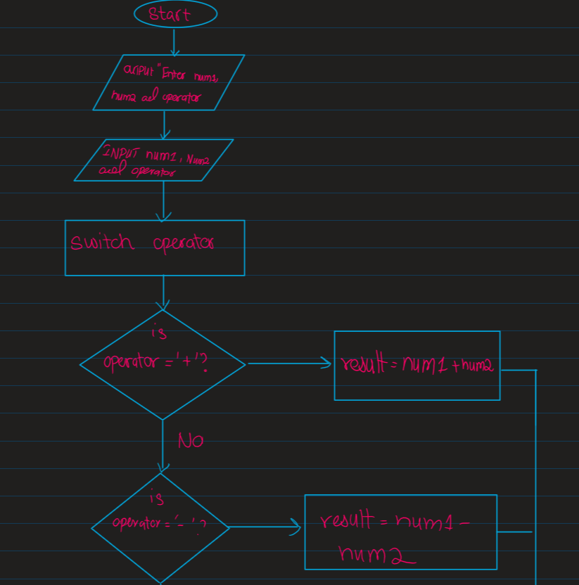

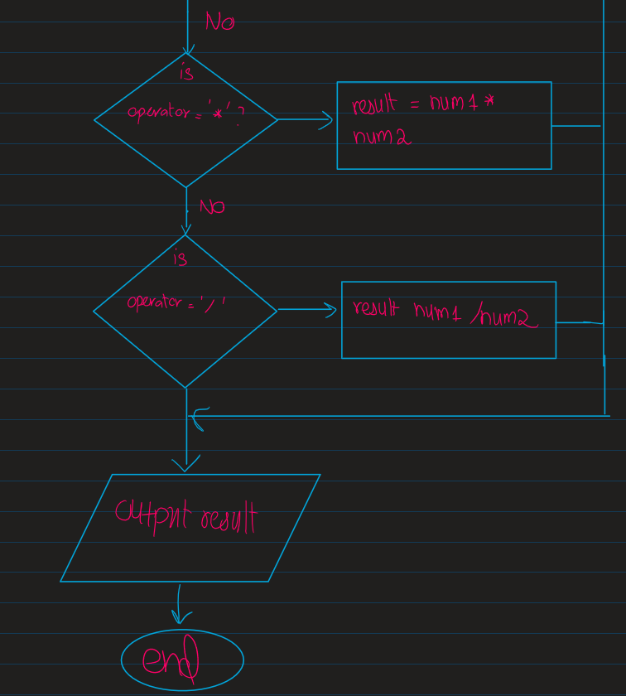

Question 3

C-code

#include <stdio.h>

int main(){

    char ch ;

    printf("Enter a character : ") ;

    scanf("%c",&ch) ;

    if(ch>='a' && ch<='z'){

        printf("%c is a small alphabet",ch) ;

    }

    else if (ch>='A' && ch<='Z'){

        printf("%c is a Capital alphabet",ch) ;

    }

    else if (ch>='0' && ch<='9'){

        printf("%c is a digit",ch) ;

    }

else{

        printf("%c is a special character",ch) ;

    }

    return 0 ;

}

Compiler’s output

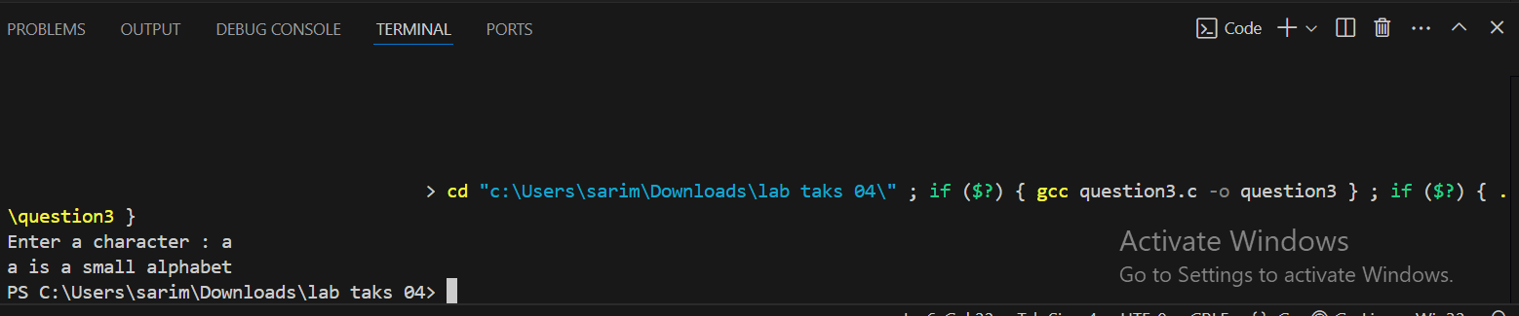

Flow chart

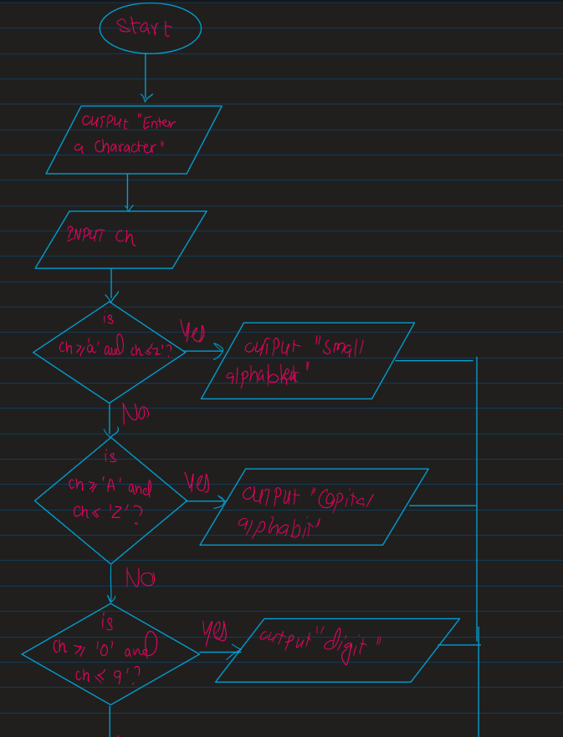

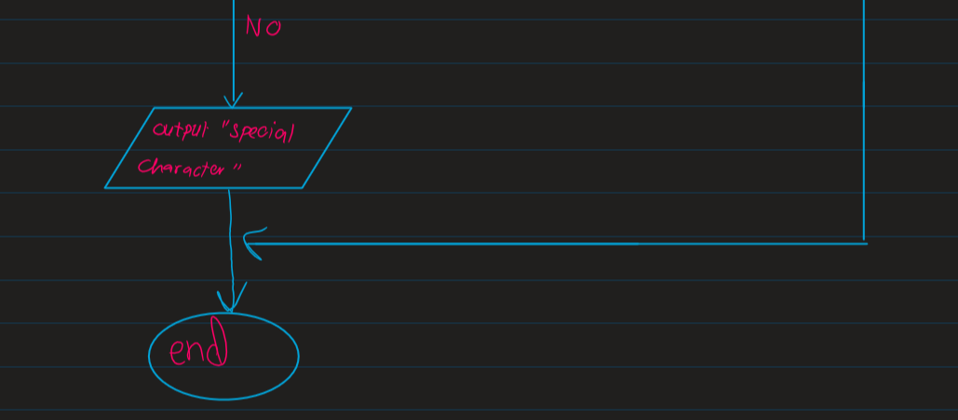

Question 4

C-code

#include <stdio.h>

int main(){

    int amount ;

    float discount ;

    printf("ENTER SHOPPING AMOUNT : ") ;

    scanf("%d",&amount) ;

    if( amount >=500 && amount< 2000 ){

        discount = amount*0.05 ;

    }

    else if(amount>=2000 && amount <4000){

        discount = amount*0.1 ;

    }

    else if(amount>=4000 && amount<6000){

        discount = amount*0.2  ;

    }

    else if(amount>=6000){

        discount  = amount*0.35 ;

    }

    else{

        printf("Your are not eligible for discount ") ;

    }

    float net_amount= amount - discount ;

    printf("Your actual amount is %d \n",amount) ;

    printf("Your discount amount is %.2f\n",discount) ;

    printf("Your amount after discount is %.2f\n ",net_amount) ;

    return 0 ;

}

Compiler’s output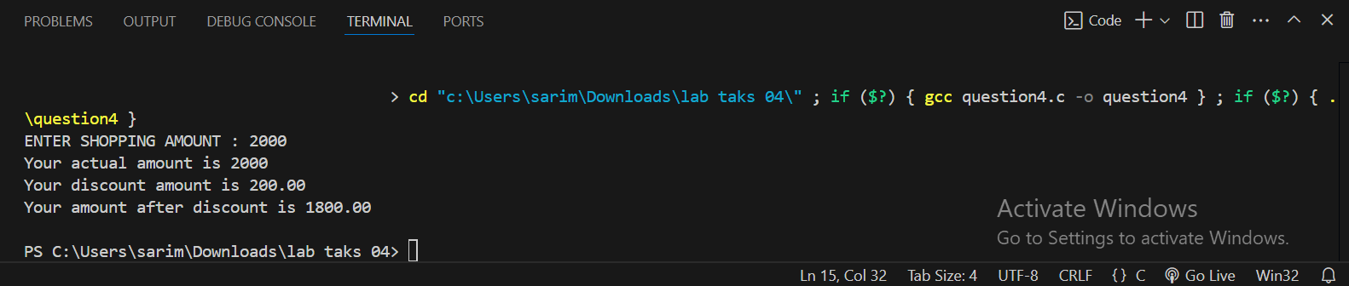

Flow chart

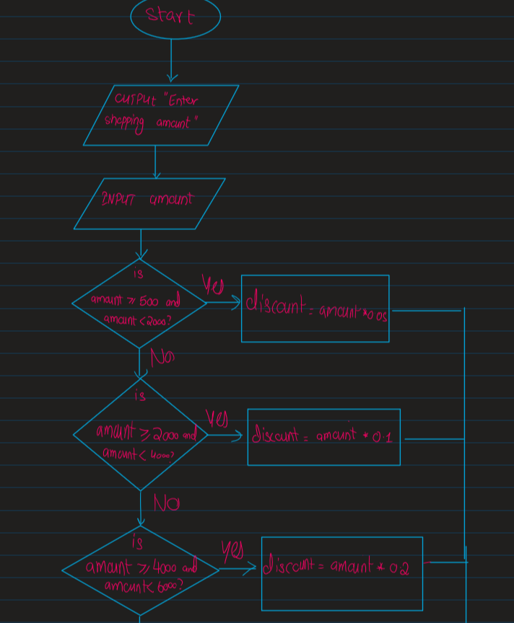

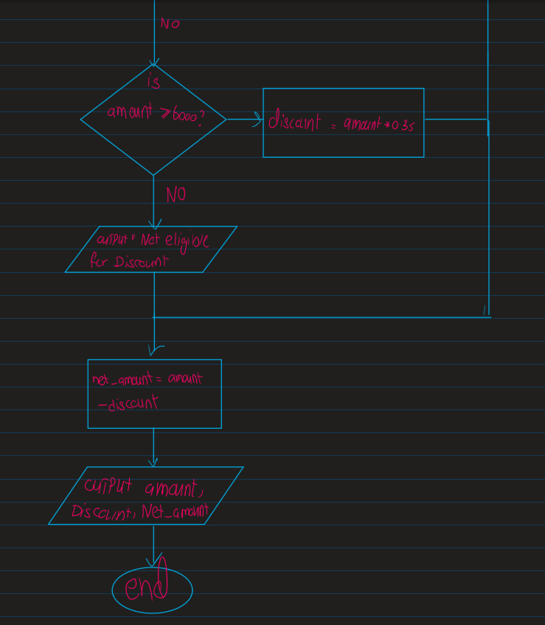

Question 5

C-code

#include <stdio.h>

int main(){

    int units,id ;

    float amount,rate ;

    char name[100] ;

    printf("Enter unit consumed in nearest integer : ") ;

    scanf("%d",&units) ;

    printf("Enter customer name  : ") ;

    scanf(" %s",&name) ;

    printf("Enter Consumwer id : ") ;

    scanf("%d",&id) ;

    if(units <=199){

        rate = 16.2 ;

        amount = rate * units ;

    }

    else if(units>=200 && units<300){

        rate = 20.1 ;

        amount = rate * units ;

    }

    else if (units>=300 && units < 500){

        rate = 27.1 ;

        amount = rate * units ;

    }

    else if(units>=500){

        rate = 35.9 ;

        amount = rate * units ;

        if (amount > 18000){

            amount = amount + amount*0.15 ;

        }

    }

    else{

        printf("Units can't be negative") ;

    }

    printf("Customer ID :%d\n",id) ;

    printf("Customer Name : %s\n",name) ;

    printf("Unit Consumed : %d\n",units) ;

    printf("Amount Charges @Rs.%.2f per unit:\n%.2f\n",rate,amount) ;

    return 0 ;

}

OUTPUT

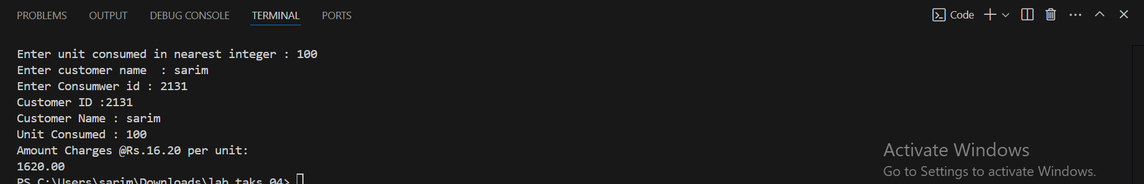

Flow Chart

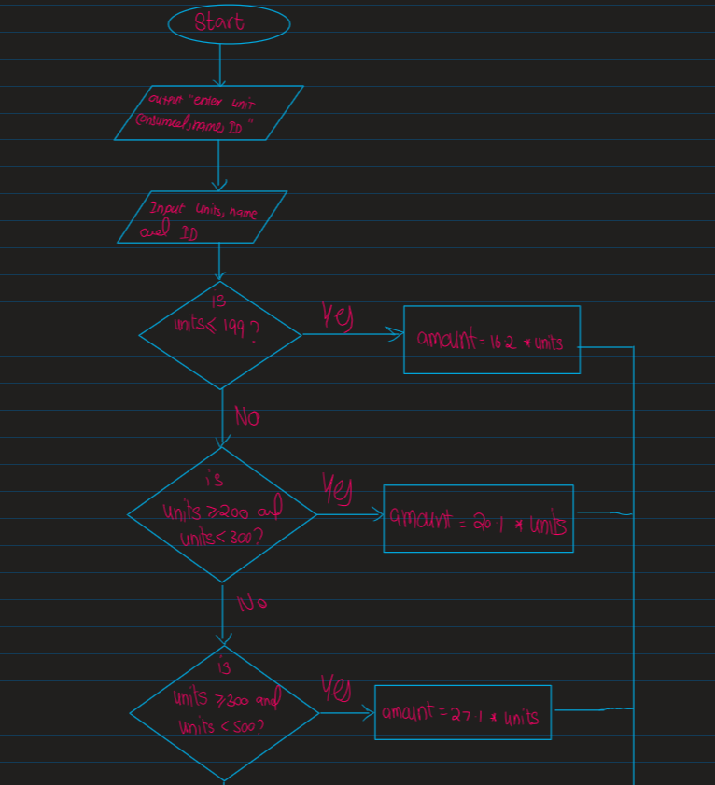

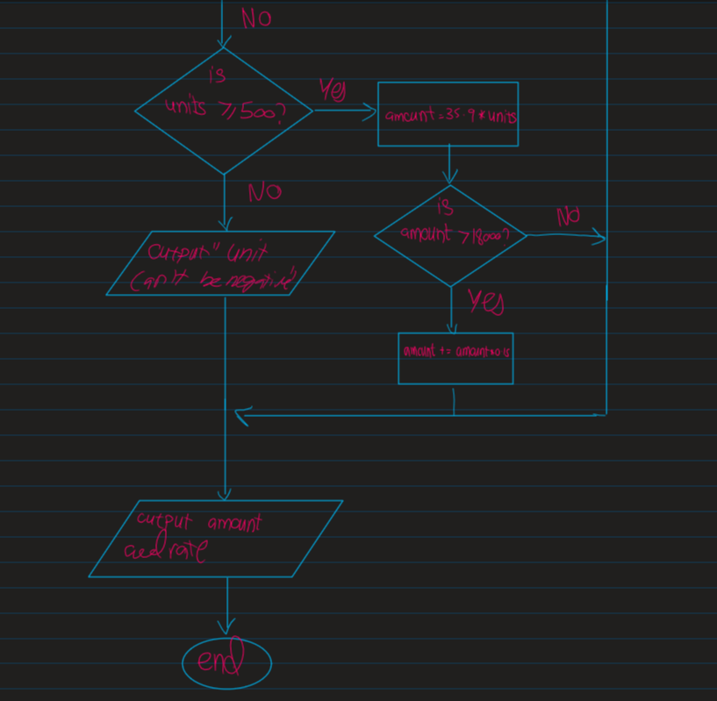

Question 6

C-code

#include <stdio.h>

int main(){

    int num ;

    printf("Enter number between 1-9 : ") ;

    scanf("%d",&num) ;

    switch(num){

        case 1 :

            printf("%d english word is one",num) ;

            break ;

        case 2 :

            printf("%d english word is two",num) ;

            break ;

        case 3 :

            printf("%d english word is three",num) ;

            break ;

        case 4 :

            printf("%d english word is four",num) ;

            break ;

        case 5 :

            printf("%d english word is five",num) ;

            break ;

        case 6 :

            printf("%d english word is six",num) ;

            break ;

        case 7 :

            printf("%d english word is seven",num) ;

            break ;

        case 8 :

            printf("%d english word is eight",num) ;

            break ;

        case 9 :

            printf("%d english word is nine",num) ;

            break ;

        default:

            printf("Greater than 9") ;

            break ;

    }

}

Complier’s output



Question 7

C-Code

#include <stdio.h>

int main(){

    int light_intensity ;

    printf("Enter Value of ligth Intensity : ") ;

    scanf("%d",&light_intensity) ;

    if(light_intensity<0 || light_intensity > 1000){

        printf("out of range") ;

    }

    else if(light_intensity>500){

        printf("Sunshine") ;

    }

    else if (light_intensity>100 || light_intensity<500){

        printf("lighting") ;

    }

    else{

        printf("evening") ;

    }

    return 0 ;

}

Compiler’s output



Question 8

C-code

#include<stdio.h>

int main(){

    int hour ;

    printf("Enter Hour : ") ;

    scanf("%d",&hour) ;

    if(hour<0 || hour> 24){

        printf("Invalid hour") ;

    }

    else if(hour>=5 && hour <=11){

        printf("Good Morning") ;

    }

    else if (hour >=12 && hour<=18){

        printf("Good Evening") ;

    }

    else if(hour>=19 && hour <=24){

        printf("Good Night") ;

    }

    return 0 ;

}

COMPLIER’S OUTPUT



QUESTION 9

#include<stdio.h>

int main(){

    int nts_marks,fsc_marks ;

    printf("Enter NTS MARKS : ") ;

    scanf("%d",&nts_marks) ;

    printf("Enter FSC MARKS : ") ;

    scanf("%d",&fsc_marks) ;

    float nts_percentage,fsc_percentage ;

    nts_percentage = (nts_marks/100)*100 ;

    fsc_percentage = (fsc_marks/1100) * 100 ;

    if(fsc_percentage>70 && nts_percentage>70){

        printf("You are eligible for IT in Oxford") ;

    }

    else if(fsc_percentage>70 && nts_percentage > 60){

        printf("You are eligible for Electronics in Oxford") ;

    }

    else if(fsc_percentage>70 && nts_percentage>50){

        printf("You are eligible for Telecommunication in Oxford") ;

    }

    if((fsc_percentage>60 && fsc_percentage<70) && nts_percentage==50){

        printf("You are eligible for IT in MIT") ;

    }

    else if((fsc_percentage>50 && fsc_percentage<59) && nts_percentage==50){

        printf("You are eligible for Chemical in MIT") ;

    }

    else if((fsc_percentage>40 && fsc_percentage<50) && nts_percentage>50){

        printf("You are eligible for Computer is MIT") ;

    }

    return 0 ;

}

Compiler’s output

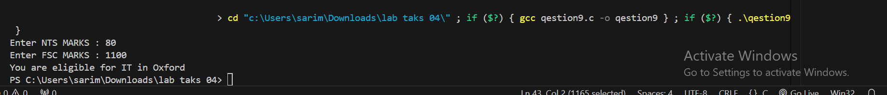

QUESTION 10

C-CODE

#include <stdio.h>

int main(){

    float temperature ;

    printf("Enter temperature : ") ;

    scanf("%f",&temperature) ;

   if(temperature<0){

    printf("Freezing cold") ;

   }

   else if(temperature>=0 && temperature<=10){

        printf("Very cold weather") ;

   }

   else if(temperature>=11 && temperature <=20){

        printf("Cold weather") ;

   }

   else if(temperature>=21 && temperature <=30) {

        printf("Normal Temperature") ;

   }

   else if(temperature>=31 && temperature <40){

        printf("Hot weather") ;

   }

    else{

        printf("Very hot weather") ;

    }

    return 0 ;

}

Compiler’s code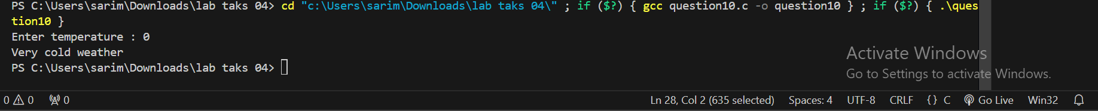

Example 1

#include <stdio.h>

int main(){

    int age ;

    printf("Enter your age : ") ;

    scanf("%d",&age) ;

    if(age>=18){

        printf("You are eligible for license") ;

    }

    else{

        printf("You are not eligible for license") ;

    }

     return 0 ;

}

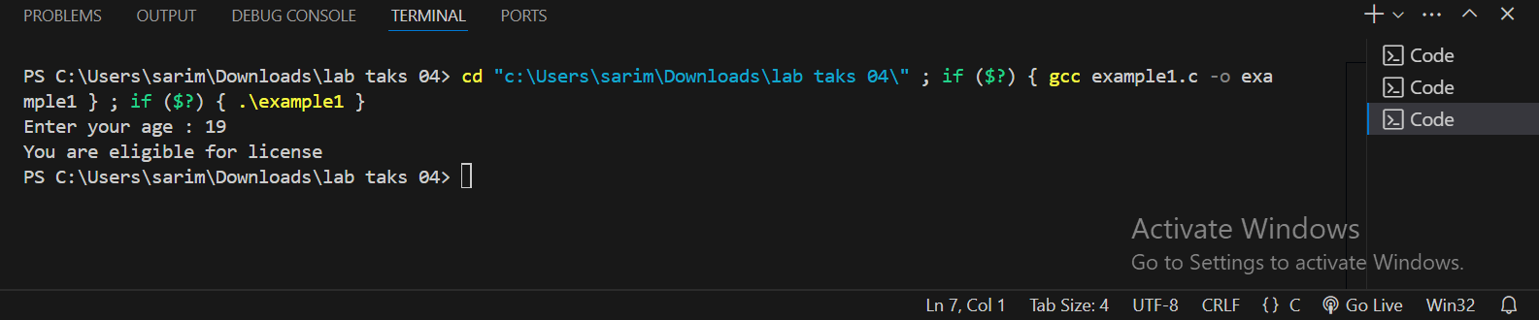

Example 2

#include <stdio.h>

int main(){

    int num ;

    printf("Enter day number from 1-7 : ") ;

    scanf("%d",&num) ;

    switch(num){

        case(1) :

            printf("Monday") ;

            break ;

        case(2) :

            printf("Tuesday") ;

            break;

        case(3) :

            printf("Wednesday") ;

            break;

        case(4) :

            printf("Thursday") ;

            break;

        case(5) :

            printf("Friday") ;

            break;

        case(6) :

            printf("Saturday") ;

            break;

        case(7) :

            printf("Sunday") ;

            break;

        default :

            printf("Invalid enter correct number") ;

            break;

    }

}

